|  |  |  |
| --- | --- | --- |
| https://upload.wikimedia.org/wikipedia/commons/thumb/4/4e/VU_Logo.png/260px-VU_Logo.png | **Operating Systems Practical (CS604p)**  **Assignment # 01**  **Spring 2023** | **Total marks = 20**  **Deadline**  **29/05/2023** |
| **Please carefully read the following instructions before attempting the assignment.**  **RULES FOR MARKING**  **It should be clear that your assignment would not get any credit if:**   * The assignment is submitted after the due date. * The submitted assignment does not open or the file is corrupt. * Strict action will be taken if the submitted solution is copied from any other student or the internet.   **You should consult the recommended books to clarify your concepts as handouts are not sufficient.**  **You are supposed to submit your assignment in Doc or Docx** **format.**  Any other formats like scan images, PDF, ZIP, RAR, PPT, BMP, etc. will not be accepted.  **You are required to send the screenshot of Question no. 1 and C Code for two programs in the same word file.**  **Assignment No. 1 covers Lab 1-5 weeks**  **The objective of this assignment is to provide hands on experience of:**   * Basic concept of Interprocess Communication Using Fifo * Compiling and running of your C program in LINUX Terminal Window (Shell Prompt) * System calls and their usage in Linux | | |
| **NOTE**  No assignment will be accepted *after the due date via email in any case* (whether it is the case of load shedding or internet malfunctioning etc.). Hence refrain from uploading assignments in the last hour of the deadline. It is recommended to upload the solution file at least two days before its closing date.  If you people find any mistake or confusion in the assignment (Question statement), please consult with your instructor before the deadline. After the deadline, no queries will be entertained in this regard.  **For any query, feel free to email at:**  **Cs604p@vu.edu.pk** | | |

**Questions No 01 20 marks**

You are required to create the two C programs to perform inter-process communication (IPC) between two separate programs in Linux, for this you can use FIFOs (named pipes) as a common communication channel. Each program will have its own source code and executable file. Following is the detail of two separate C programs: one for the writer process and another for the reader process.

* In the writer program (writer.c) will open the FIFO in write-only mode and write a message to it. The writer program will send the message "Hello from writer program!" to the FIFO. Secondly writer program will run in background.
* The reader program (reader.c) will open the FIFO in read-only mode and read the message from it, then reader program will read and display the message.

Following are the steps to be performed in your assignment for compiling/running of your program.

1. Before running the programs, make sure to create the FIFO using the mkfifo command at command prompt:

**mkfifo /tmp/myfifo**

**b)**Then, compile each program separately using the following commands:

**gcc writer.c -o writer.out**

**gcc reader.c -o reader.out**

**c)**Then, you can run the writer program in background and the reader program in foreground as follows:

**./writer &**

**./reader**

**d)**Remember to clean up the FIFO afterward by removing it with the unlink command:

**unlink /tmp/myfifo**

Following is the screenshot:

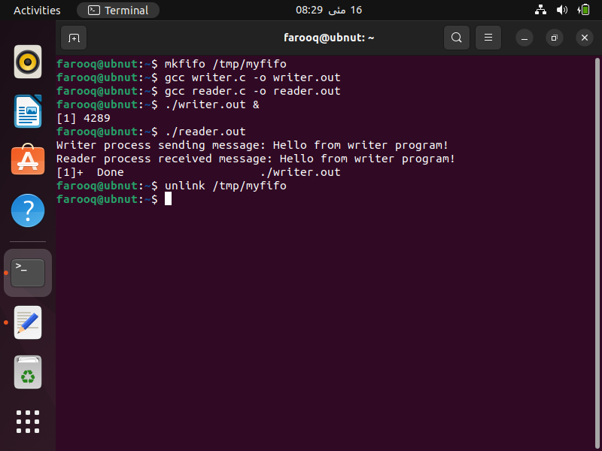

See the following link for installation of Virtual Box and Ubuntu (Linux) on your system.

<https://vulms.vu.edu.pk/CourseResources/OpenFile.aspx?File=tutorial_for_installing_virtualbox_and_ubuntu.mp4>

See the following link for installing gcc and compiling your first program in Linux.

<https://vulms.vu.edu.pk/CourseResources/OpenFile.aspx?File=How%20to%20install%20gcc%20on%20Ubuntu%20and%20compile%20a%20C%20program.mp4>

**Note:** in case you have installed the Virtual Box you can take the screenshot as follows. Go to **view** menu and click on **Take Screenshot** as follow.

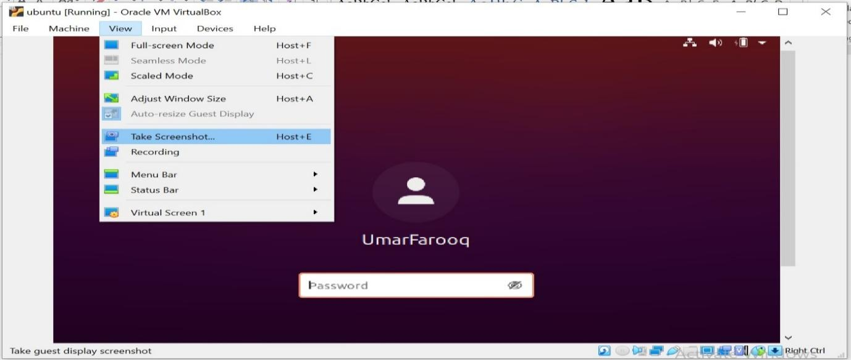

The End